**PROJECT**

**Intruder detection and alerting system**

Project Description:

Features:

* There will be a camera integrated in the premises
* In the live video streaming the images will be capture at some time intervals and given as an input to IBM visual recognition service.
* if any intruder is detected the images will be captured and sent to IBM COS
* Authorities can see the images through web app
* the admin can switch on / off the system based on the requirement.

.

**Node RED:**

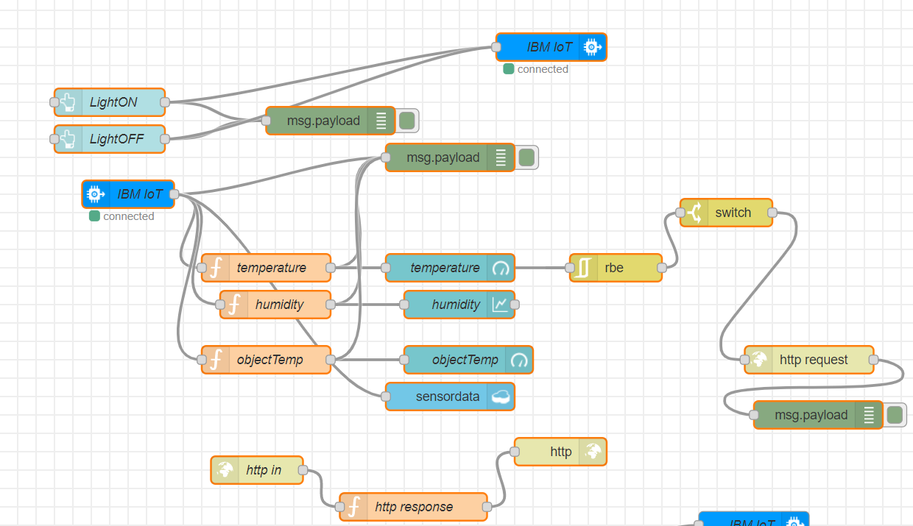

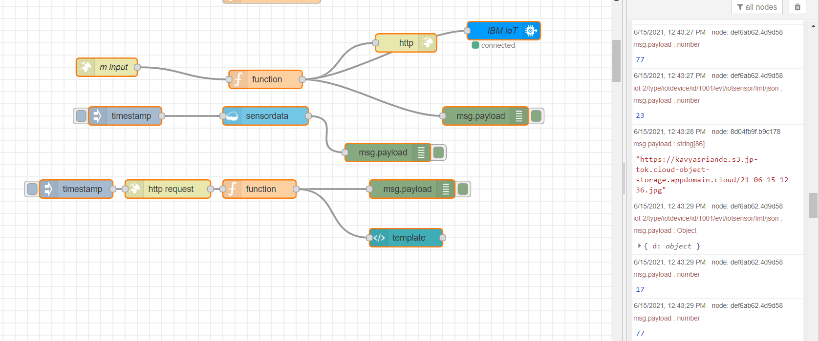

**Node RED UI:**

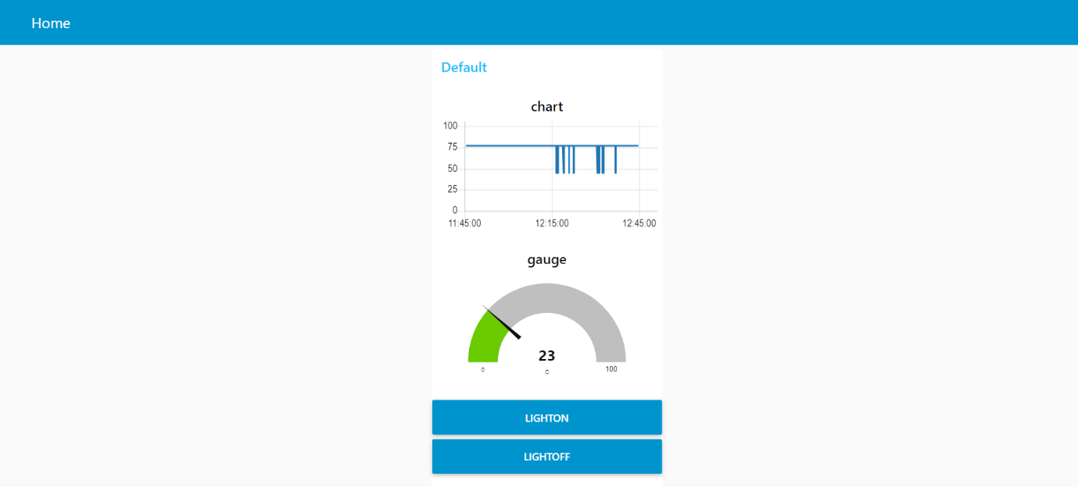

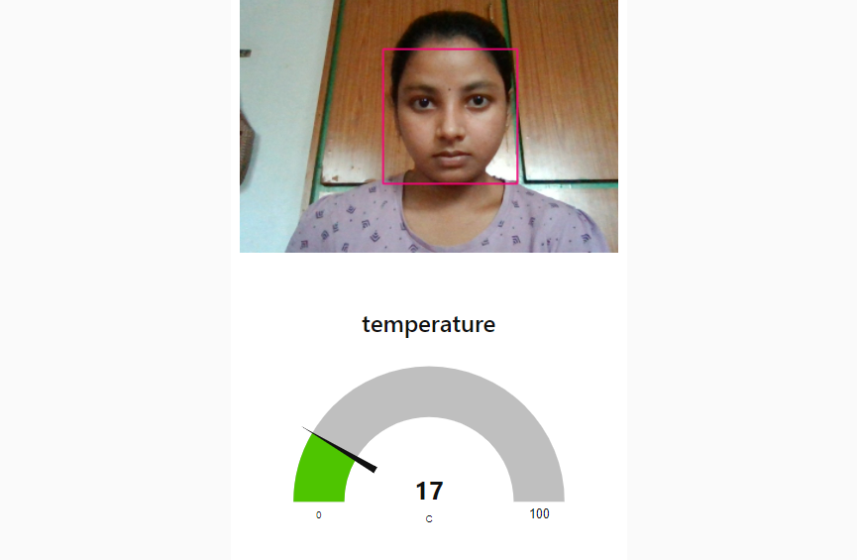

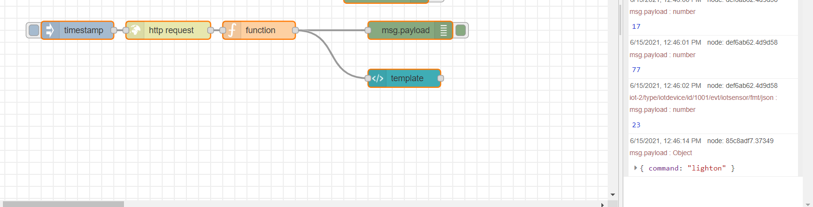**When the LIGHT ON is pressed in the UI:**

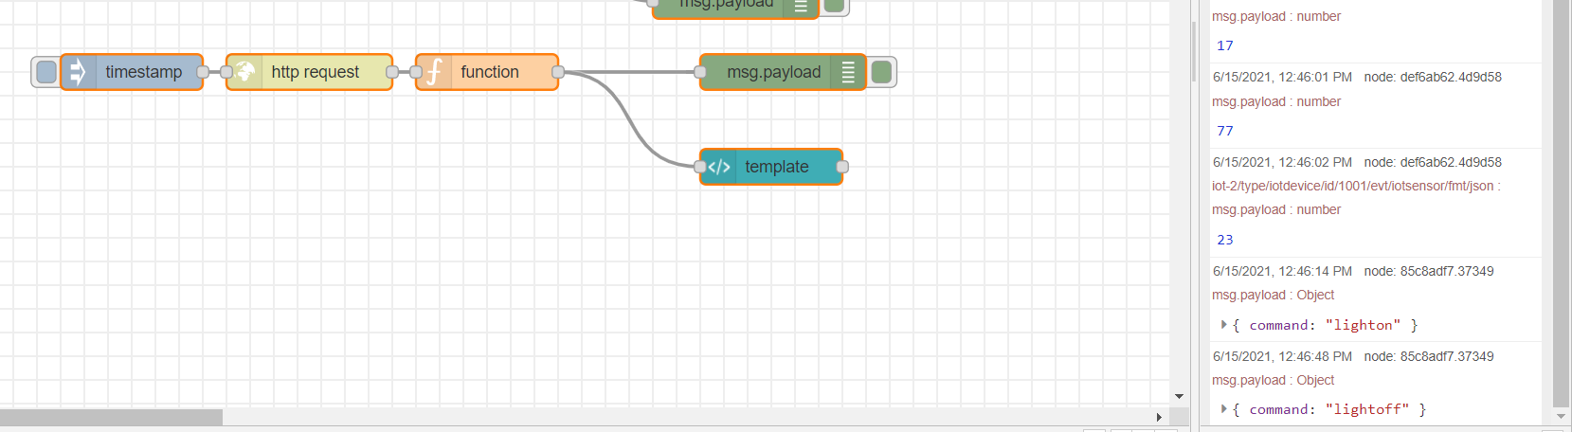**When the LIGHT OFF is pressed in the UI:**

**DATABASE OUTPUT:**

